Sri Lanka Institute of Information Technology

IT1040 - Fundamentals of Computing

Year 1, Semester 1- 2024

**Aqua Guard**

**Smart Water Tank Monitoring System**

Progress Report

G09.01 - PG01

|  |  |
| --- | --- |
| IT Number | Name |
| IT24102870 | Jayasundara M. H. L. J. |
| IT24102019 | Balasooriya N. N. |
| IT24102178 | Peiris W. U. M. |
| IT24102126 | Silva K. N. T. |
| IT24100400 | Sandeepa M. S. |
| IT24100162 | Suriyaarachchi R. H. |

# Introduction

Water scarcity is an escalating global challenge, affecting millions of people and putting immense pressure on natural resources. Efficient water management is crucial to ensuring sustainability and meeting the growing demand for this vital resource. Traditional methods of monitoring water levels in tanks often rely on manual inspection, which can be inefficient, inaccurate, and time-consuming. This leads to frequent issues such as water wastage, overflow, and insufficient supply management in many residential, commercial, and industrial settings.

The advancement of IoT (Internet of Things) technologies offers a promising solution to these challenges. Integrating smart sensors and automation into water management systems optimizes water usage and reduces wastage. “Aqua Guard” – a smart water tank monitoring system aims to develop a water tank monitoring system that leverages modern technology to provide accurate, real-time data on water levels and consumption patterns, thereby enhancing water management practices and contributing to environmental sustainability efforts.

# System Architecture

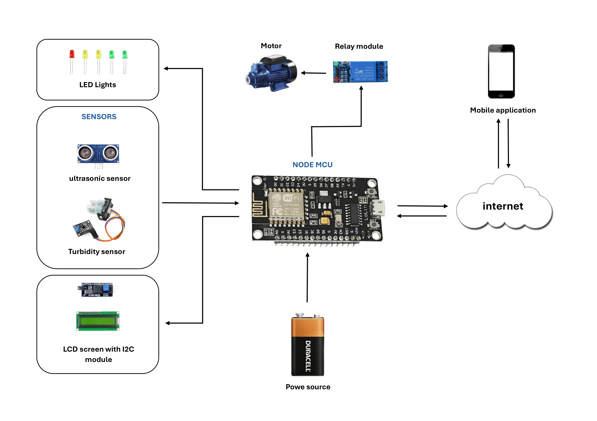

The smart water tank monitoring system in the provided architecture is designed to monitor and control water levels using various sensors, a relay, and a motor, all connected to a NodeMCU (ESP8266) for communication and automation.

* **Ultrasonic Sensor (HC-SR04):** Measures the water level in the tank by calculating the distance between the sensor and the water surface.
* **Turbidity Sensor:** Monitors the water quality by measuring the level of impurities in the water.
* **LED Lights:** Different colored LEDs indicate the water level and water quality status. For example, green for normal levels, yellow for warning, and red for critical conditions.
* **Relay Module (HW-307):** Controls the motor, which pumps water into or out of the tank. The relay acts as a switch that is controlled by the NodeMCU.
* **Motor:** Pumps water based on the signal received from the relay. It is turned on/off to maintain the desired water level in the tank.
* **NodeMCU (ESP8266):** Central processing unit that connects to the sensors, relay module, and LEDs. It collects data from the sensors, processes it, and makes decisions on whether to activate the motor via the relay module. It also communicates with the cloud or mobile application through Wi-Fi, providing real-time water level and quality data.
* **Mobile Application:** Users can monitor the water level and water quality remotely through a mobile app. The NodeMCU sends data to the cloud, which is accessed by the app for real-time updates. The app can also be used to manually control the motor if necessary.

**How the System Works:**

1. The ultrasonic sensor continuously monitors the water level in the tank, sending data to the NodeMCU.
2. The turbidity sensor checks the water quality, ensuring it is safe for use.
3. Based on the water level and quality readings, the NodeMCU processes the data:
   * If the water level is low, the NodeMCU activates the relay, which turns on the motor to pump water into the tank.
   * If the water level is sufficient, the motor is turned off.
4. LED lights provide a visual indication of the water level and quality.
5. All sensor data is transmitted to a mobile application via the internet, allowing remote monitoring and control of the system.

# Work Breakdown Structure

# Proof of Work